Lab - Configure and Verify eBGP

1. Topology

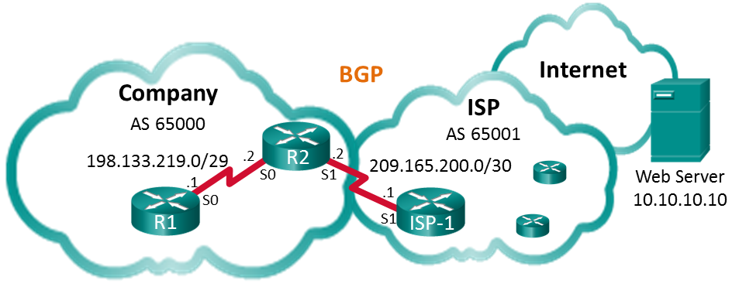

1. Addressing Table

|  |  |  |  |
| --- | --- | --- | --- |
| Device | Interface | IP Address | Subnet Mask |
| R1 | S0/0/0 (DCE) | 198.133.219.1 | 255.255.255.248 |
| R2 | S0/0/0 | 198.133.219.2 | 255.255.255.248 |
| S0/0/1 (DCE) | 209.165.200.2 | 255.255.255.252 |
| ISP-1 | S0/0/1 | 209.165.200.1 | 255.255.255.252 |
| Web Server |  | 10.10.10.10 | 255.255.255.255 |

Objectives

Part 1: Build the Network and Configure Basic Device Settings

Part 2: Configure eBGP on R1

Part 3: Verify eBGP Configuration

1. Background / Scenario

In this lab you will configure eBGP for the Company. The ISP will provide the default route to the Internet. Once configuration is complete you will use various **show** commands to verify that the eBGP configuration is working as expected.

1. Required Resources

* 3 Routers (Cisco 1941 with Cisco IOS Release 15.2(4)M3 universal image or comparable)
* Console cables to configure the Cisco IOS devices via the console ports
* Serial cables as shown in the topology

1. Build the Network and Configure Basic Device Settings

In Part 1, you will set up the network topology and configure basic settings on R1 and R2 routers. You will also copy the provided configuration for ISP-1 on to that router.

* 1. Cable the network as shown in the topology.
  2. Initialize and reload the network devices as necessary.
  3. Configure basic settings on R1 and R2.
     1. Disable DNS lookup to prevent the routers from attempting to translate incorrectly entered commands as though they were host names.
     2. Configure the hostnames according to the topology.
     3. Configure interfaces according to the Addressing Table.
     4. Save the running configuration to the startup configuration file.
  4. Copy configuration to ISP-1.

Copy and paste the following configuration to ISP-1.

hostname ISP-1

no ip domain-lookup

interface Loopback0

ip address 10.10.10.10 255.255.255.255

interface Serial0/0/1

ip address 209.165.200.1 255.255.255.252

no shut

ip route 0.0.0.0 0.0.0.0 lo0

router bgp 65001

bgp log-neighbor-changes

network 0.0.0.0

neighbor 209.165.200.2 remote-as 65000

end

1. Configure eBGP on R2

Configure R2 to become an eBGP peer with ISP-1. Refer to the Topology for BGP AS number information.

* 1. Enable BGP and identify the AS number for the Company.

R2(config)# **router bgp 65000**

* 1. Use the neighbor command to identify ISP-1 as the BGP peer.

R2(config-router)# **neighbor 209.165.200.1 remote-as 65001**

* 1. Add the Company’s network to the BGP table so it is advertised to ISP-1.

R2(config-router)# **network 198.133.219.0 mask 255.255.255.248**

1. Verify eBGP Configuration

In Part 3, use the BGP verifications commands to verify that the BGP configuration is working as expected.

* 1. Display the IPv4 routing table on R2.

R2# **show ip route**

Codes: L - local, C - connected, S - static, R - RIP, M - mobile, B - BGP

D - EIGRP, EX - EIGRP external, O - OSPF, IA - OSPF inter area

N1 - OSPF NSSA external type 1, N2 - OSPF NSSA external type 2

E1 - OSPF external type 1, E2 - OSPF external type 2

i - IS-IS, su - IS-IS summary, L1 - IS-IS level-1, L2 - IS-IS level-2

ia - IS-IS inter area, * - candidate default, U - per-user static route

o - ODR, P - periodic downloaded static route, H - NHRP, l - LISP

a - application route

+ - replicated route, % - next hop override

Gateway of last resort is 209.165.200.1 to network 0.0.0.0

B* 0.0.0.0/0 [20/0] via 209.165.200.1, 00:00:07

198.133.219.0/24 is variably subnetted, 2 subnets, 2 masks

C 198.133.219.0/29 is directly connected, Serial0/0/0

L 198.133.219.2/32 is directly connected, Serial0/0/0

209.165.200.0/24 is variably subnetted, 2 subnets, 2 masks

C 209.165.200.0/30 is directly connected, Serial0/0/1

L 209.165.200.2/32 is directly connected, Serial0/0/1

* 1. Display the BGP table on R2.

R2# **show ip bgp**

BGP table version is 4, local router ID is 209.165.200.2

Status codes: s suppressed, d damped, h history, * valid, > best, i - internal,

r RIB-failure, S Stale, m multipath, b backup-path, f RT-Filter,

x best-external, a additional-path, c RIB-compressed,

Origin codes: i - IGP, e - EGP, ? - incomplete

RPKI validation codes: V valid, I invalid, N Not found

Network Next Hop Metric LocPrf Weight Path

*> 0.0.0.0 209.165.200.1 0 0 65001 i

*> 198.133.219.0/29 0.0.0.0 0 32768 i

* 1. Display the BGP connection status on R2.

R2# **show ip bgp summary**

BGP router identifier 209.165.200.2, local AS number 65000

BGP table version is 4, main routing table version 4

2 network entries using 288 bytes of memory

2 path entries using 160 bytes of memory

2/2 BGP path/bestpath attribute entries using 320 bytes of memory

1 BGP AS-PATH entries using 24 bytes of memory

0 BGP route-map cache entries using 0 bytes of memory

0 BGP filter-list cache entries using 0 bytes of memory

BGP using 792 total bytes of memory

BGP activity 2/0 prefixes, 2/0 paths, scan interval 60 secs

Neighbor V AS MsgRcvd MsgSent TblVer InQ OutQ Up/Down State/PfxRcd

209.165.200.1 4 65001 12 11 4 0 0 00:06:56 1

* 1. Display the IPv4 routing table on ISP-1.

Verify that the 198.133.218.0/29 network is being advertised to the ISP-1 router.

ISP-1# **show ip route**

Codes: L - local, C - connected, S - static, R - RIP, M - mobile, B - BGP

D - EIGRP, EX - EIGRP external, O - OSPF, IA - OSPF inter area

N1 - OSPF NSSA external type 1, N2 - OSPF NSSA external type 2

E1 - OSPF external type 1, E2 - OSPF external type 2

i - IS-IS, su - IS-IS summary, L1 - IS-IS level-1, L2 - IS-IS level-2

ia - IS-IS inter area, * - candidate default, U - per-user static route

o - ODR, P - periodic downloaded static route, H - NHRP, l - LISP

a - application route

+ - replicated route, % - next hop override

Gateway of last resort is 0.0.0.0 to network 0.0.0.0

S* 0.0.0.0/0 is directly connected, Loopback0

10.0.0.0/32 is subnetted, 1 subnets

C 10.10.10.10 is directly connected, Loopback0

198.133.219.0/29 is subnetted, 1 subnets

B 198.133.219.0 [20/0] via 209.165.200.2, 00:00:25

209.165.200.0/24 is variably subnetted, 2 subnets, 2 masks

C 209.165.200.0/30 is directly connected, Serial0/0/1

L 209.165.200.1/32 is directly connected, Serial0/0/1

Ping the Web Server from R1. Were the pings successful? (**Note:** For the pings to succeed, a static default route must be configured on R1 using the serial 0/0/0 interface as the exit interface.)

_______________________________________________________________________________________

1. Reflection

The topology used in this lab was created to demonstrate how to configure the BGP routing protocol. However, the BGP protocol would not normally be configured for a topology like this in the real world. Explain.

_______________________________________________________________________________________

_______________________________________________________________________________________

_______________________________________________________________________________________

_______________________________________________________________________________________

1. Router Interface Summary Table

|  |  |  |  |  |
| --- | --- | --- | --- | --- |
| Router Interface Summary | | | | |
| Router Model | Ethernet Interface #1 | Ethernet Interface #2 | Serial Interface #1 | Serial Interface #2 |
| 1800 | Fast Ethernet 0/0 (F0/0) | Fast Ethernet 0/1 (F0/1) | Serial 0/0/0 (S0/0/0) | Serial 0/0/1 (S0/0/1) |
| 1900 | Gigabit Ethernet 0/0 (G0/0) | Gigabit Ethernet 0/1 (G0/1) | Serial 0/0/0 (S0/0/0) | Serial 0/0/1 (S0/0/1) |
| 2801 | Fast Ethernet 0/0 (F0/0) | Fast Ethernet 0/1 (F0/1) | Serial 0/1/0 (S0/1/0) | Serial 0/1/1 (S0/1/1) |
| 2811 | Fast Ethernet 0/0 (F0/0) | Fast Ethernet 0/1 (F0/1) | Serial 0/0/0 (S0/0/0) | Serial 0/0/1 (S0/0/1) |
| 2900 | Gigabit Ethernet 0/0 (G0/0) | Gigabit Ethernet 0/1 (G0/1) | Serial 0/0/0 (S0/0/0) | Serial 0/0/1 (S0/0/1) |
| **Note**: To find out how the router is configured, look at the interfaces to identify the type of router and how many interfaces the router has. There is no way to effectively list all the combinations of configurations for each router class. This table includes identifiers for the possible combinations of Ethernet and Serial interfaces in the device. The table does not include any other type of interface, even though a specific router may contain one. An example of this might be an ISDN BRI interface. The string in parenthesis is the legal abbreviation that can be used in Cisco IOS commands to represent the interface. | | | | |